**Feature-Driven Development:**

**FDD** stands for **Feature-Driven Development**.

It is an agile iterative and incremental model that focuses on progressing the features of the developing software.

The main motive os feature-driven development is to provide timely updated and working software to the client. In FDD, reporting and progress tracking is necessary at all levels.

**FDD Lifecycle:**

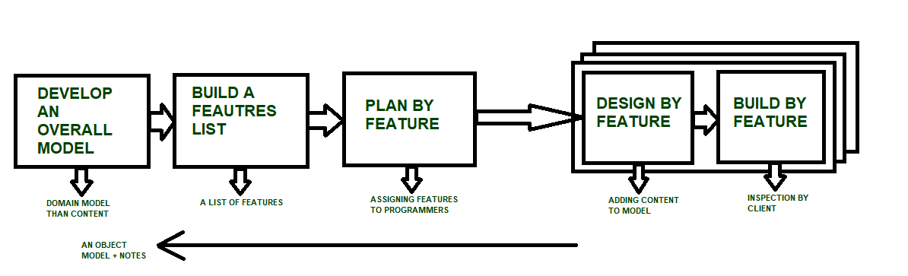

#### Advantages of FDD

* Reporting at all levels leads to easier progress tracking.
* FDD provides continuous success for larger size of teams and projects.
* Reduction in risks is observed as whole model and design is build in smaller segments.
* FDD provides greater accuracy in cost estimation of the project due to feature segmentation.

#### Disadvantages of FDD

* This agile practice is not good for smaller projects.
* There is high dependency on lead programmers, designers and mentors.
* There is lack of documentation which can create an issue afterwards.